ST. XAVIER’S COLLEGE

**(Affiliated to Tribhuvan University)**

Maitighar, Kathmandu



COMPUTER GRAPHICS

Lab Assignment #7

**Submitted by:**

Linus Dhakal  
013BSCCSIT022

**Submitted to:**

|  |  |
| --- | --- |
| Er. Anil K. Sah  Lecturer |  |

Department of Computer Science

Date of Submission: September 1, 2015

**STATEMENT: WAP USING C++ BUILDER TO PERFORM THE OPERATIONS OF TRANSLATION, SCALING AND ROTATION IN THE IMAGE.**

**Source Code:**

//---------------------------------------------------------------------------

#include <vcl\vcl.h>

#pragma hdrstop

#include "TRANS.h"

#include "MATH.h"

//---------------------------------------------------------------------------

#pragma resource "*.dfm"

TForm1 *Form1;

int Tx,Ty,i,j,a,b,x,y;

//---------------------------------------------------------------------------

__fastcall TForm1::TForm1(TComponent* Owner)

: TForm(Owner)

{

}

//---------------------------------------------------------------------------

void __fastcall TForm1::TRANSLATEClick(TObject *Sender)

{

Tx=StrToInt(Edit1->Text);

Ty=StrToInt(Edit2->Text);

x=Image1->Height;

y=Image1->Width;

for (i=0;i<=x;i++)

{

for (j=0;j<=y;j++)

{

a = i+Tx;

b = j+Ty;

Image3->Canvas->Pixels[a][b]=Image1->Canvas->Pixels[i][j];

}

}

}

//---------------------------------------------------------------------------

void __fastcall TForm1::SCALINGClick(TObject *Sender)

{

Tx=StrToInt(Edit3->Text);

Ty=StrToInt(Edit4->Text);

x=Image1->Height;

y=Image1->Width;

for (i=0;i<=x;i++)

{

for (j=0;j<=y;j++)

{

a = i*Tx;

b = j*Ty;

Image2->Canvas->Pixels[a][b]=Image1->Canvas->Pixels[i][j];

}

}

}

//---------------------------------------------------------------------------

void __fastcall TForm1::RotateClick(TObject *Sender)

{

int x,y,rot,a,b,i,j;

x=Image1->Height;

y=Image1->Width;

rot=StrToInt(Edit5->Text);

for(i=0;i<=x;i++)

{

for(j=0;j<=y;j++)

{

a=i*cos(rot)-j*sin(rot);

b=j*cos(rot)+i*sin(rot);

Image4->Canvas->Pixels[a][b]=Image1->Canvas->Pixels[i][j];

}

}

}

//---------------------------------------------------------------------------

**Output:**

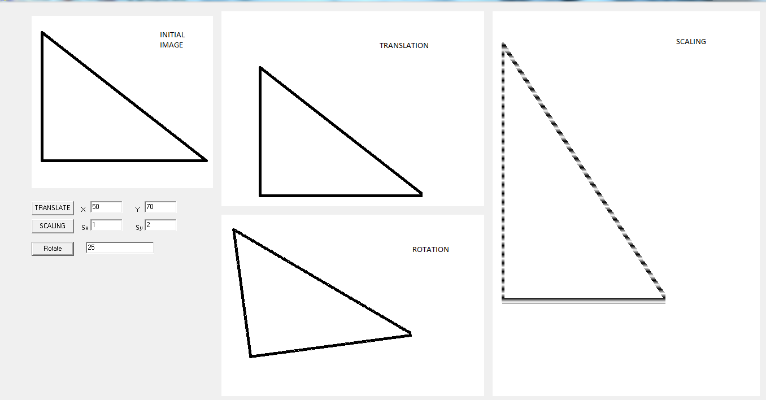

**Conclusion:**

Hence, we were able to perform the operation of translation, scaling and rotation in the given image.